Project Design Phase-II
Data Flow Diagram & User Stories

Date | 16 February 2026
Team ID | LTVIP2026TMIDS74755
Project Name | Rising Waters: A Machine Learning Approach To Flood Prediction
Maximum Marks | 4 Marks

Data Flow Diagrams:
A Data Flow Diagram (DFD) is a traditional visual representation of the information flows within a system. A neat and clear DFD can depict the right amount of the system requirement graphically. It shows how data enters and leaves the system, what changes the information, and where data is stored.

DFD Level 0 (Context Level)

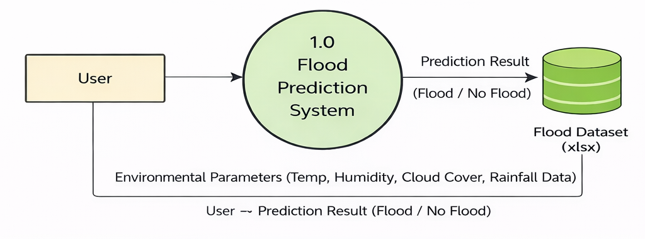
DFD Level 1 (Detailed Level)
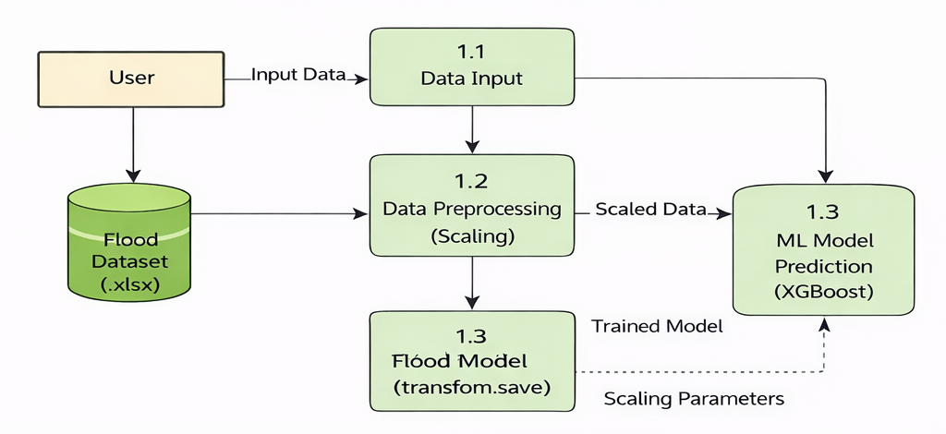

User Stories
Use the below template to list all the user stories for the product.
User Type | Functional Requirement (Epic) | User Story Number | User Story / Task | Acceptance criteria | Priority | Release
Customer  (Web User) | Access Application | USN-1 | As a user, I can access the flood prediction website | Website loads successfully | High | Sprint-1
Customer  (Web User) | Enter Input Data | USN-2 | As a user, I can enter environmental parameters for prediction | Input fields accept valid values | High | Sprint-1
Customer  (Web User) | Get Prediction | USN-3 | As a user, I can receive flood prediction result | System displays Flood / No Flood | High | Sprint-1
Customer  (Web User) | Input Validation | USN-4 | As a user, I should not submit empty or invalid inputs | Error message shown for invalid input | Medium | Sprint-1
Administrator | Model Training | USN-5 | As an admin, I can train and update the ML model | Model saved successfully as floods.save | High | Sprint-1
Administrator | Model Evaluation | USN-6 | As an admin, I can evaluate model accuracy | Accuracy metrics displayed | Medium | Sprint-1

